Name:____________________________________________ Date:________________ Period: _______

HW Quiz - A (10 Points)

An object’s motion is displaced on the graph shown. Right is defined as a positive. Be sure to include proper units with your calculated answers.
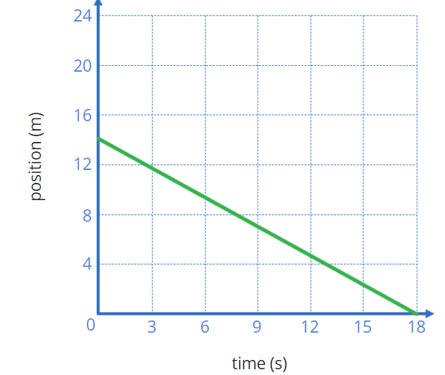
1) What is the direction of the motion?

2) What is the distance traveled?

3) What is the speed of the object?

4) Complete the table below:

Quantity | Symbol/Variable | Standard (SI) Unit
 | Δx
velocity
 |  | s

Name:____________________________________________ Date:________________ Period: _______

HW Quiz – Make-up (10 Points)

An object’s motion is displayed on the graph shown. Right is defined as a positive. Be sure to include proper units with your calculated answers.
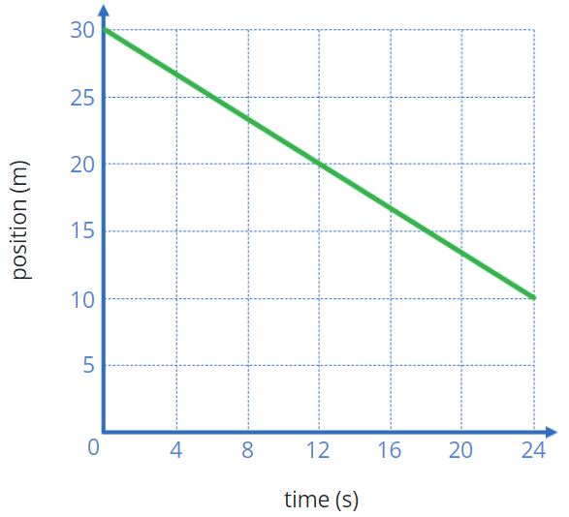
1) What is the direction of the motion?

2) What is the distance traveled after 18s?

3) What is the speed of the object at the 12s mark?

4) Complete the table below:

Quantity | Symbol/Variable | Standard (SI) Unit
Position
 | v
Time

Name:____________________________________________ Date:________________ Period: _______

HW Quiz - C (6 Points)

An object’s motion is displayed on the graph shown. Right is defined as a positive. Be sure to include proper units with your calculated answers.
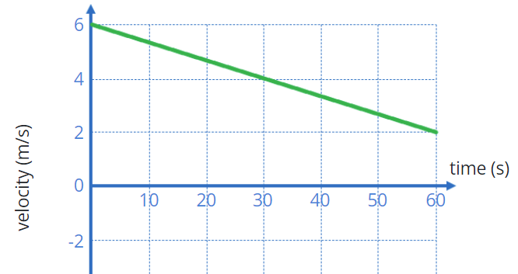
1) What is the direction of the motion?

2) What is the distance traveled?

3) What is the final speed of the object?

Name:____________________________________________ Date:________________ Period: _______

HW Quiz - D (6 Points)

An object’s motion is displayed on the graph shown. Right is defined as a positive. Be sure to include proper units with your calculated answers.
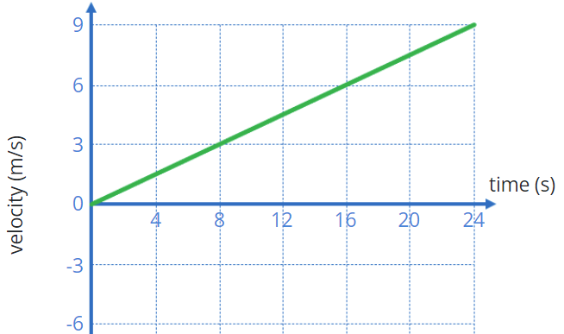
1) What is the direction of the motion?

2) What is the distance traveled?

3) What is the final speed of the object?

